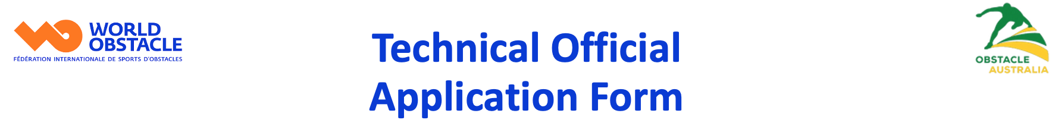

Please either 1) print this form out, complete in pen, scan or take a photo and submit
or 2) download as a Word file, complete and submit as a Word file along with any evidence you may need to attach.
Submit to: officials@worldobstacle.org

Name:
Email Address:
Home Address:
Mobile Phone Number:
Date of birth:
Club:

Sub-Sport, (please tick): ☐ Ninja
☐ Cross Country Obstacle Course Racing
☐ Track
Note: A separate application needs to be made for each sub-sport

This application is to level up to level 3 Certified International Judge/ International Technical Official (ITO)

Requirements for this level certification
Level 1 and 2 certification
Officiated at one (1) International Championship or International Series event.
Recommendation by a level 3 + Technical Official or a Continental/FISO development lead.

Level 1 requirements complete  - Pass the written exam  - Safeguard certificate,  - National background check  - Level one certificate issued | Level 2 requirements complete  - All level one requirements complete  - Race TO event 1  - Race TO event 2  - Race TO event 3  - Officiated at one National Federation sanctioned event  - Follow the level 2 module  - Pass the written exam
Level 3 requirements complete
- Event: International Federation sanctioned event.
- Fluency in English
- Excellent communication skills with athletes, officials and other judges
- Advanced knowledge of Rules
- Perfect communication of decisions
- Seeking and responding positively to feedback
- Consistent application of judges’ best practices
- Ability to make clear and correct decisions under pressure
- Performance Evaluation acting as a Chief Technical Official during an International competition
- Written self-reflection report about at least 2 events where you were part of the competition jury
- Written self-reflection report about at least 2 events where you were a CTO or ACTO

Evidence required for this application
Although no hourly limits are set for the officiating experience criteria. The amount of experience should be appropriate for the expectations at the level.

Level 3 requirements
- All level 1 and level 2 requirements previously complete and filed with the WO Technical Officials Committee YES / NO

- IF NO, please complete level 1 and 2 requirements prior to completing this application or contact an administrator for assistance

- Follow the WADA anti doping course and provide a certificate

- Officiated at one (1) International Championship or International Series event.
Location: Event Date:
Supervisor:
TO Duties Performed:

- Additional locations (not required)
Location: Event Date:
Supervisor:
TO Duties Performed:

- Additional locations (not required)
Location: Event Date:
Supervisor:
TO Duties Performed:

- Level 3+ Technical Official who is recommending you for level 3:
Name of reporter:
Level of reporter
Location of event:
Date or report:
**Please attach copy of report from above named reporter: (WORLD OBSTACLE: Report on the ability to act as a technical official)

By my signature, I attest that the information on this application is true and accurate to the best of my knowledge.

Signed: ____________________________ Date: ___________

This fully completed and signed application form should be submitted to officials@worldobstacle.org

Office use only

Previous level 1, 2 and 3 requirements on file
Officiated at 1 international Championship or International Series event.
(WORLD OBSTACLE: Report on the ability to act as a technical official)
Written Report from level 4+ Technical Official
Recommendation checked YES / NO

Checked by & date:

Level 3 approved by and date:

Issue Date:

